**VLOOKUP**

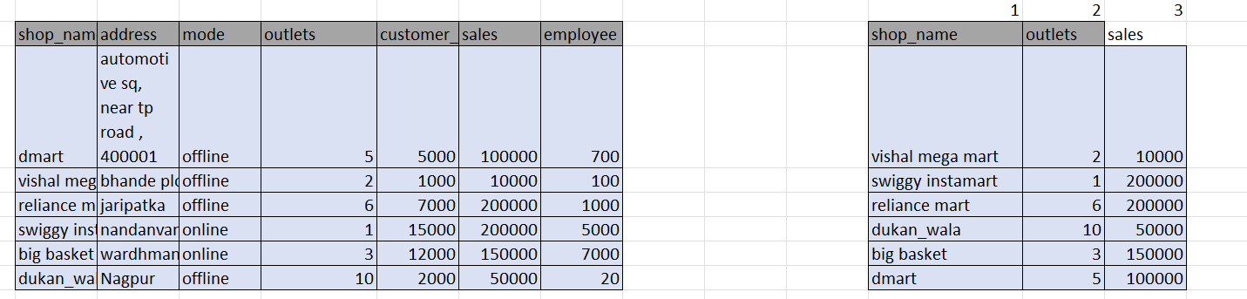

Based on the image you've uploaded, you're looking for information about **VLOOKUP**.

VLOOKUP is an **Excel function** used to **search for a value in one column and return a corresponding value from a different column in the same row**. The "V" in VLOOKUP stands for "vertical," as it works with data arranged in vertical columns. It's a very common tool for merging data from two different tables that share a common field.

**How it Works ⚙️**

The basic syntax for VLOOKUP is:

VLOOKUP(lookup_value, table_array, col_index_num, [range_lookup])

* **lookup_value**: The value you want to look for. In your example, this might be a shop_name like "dmart".
* **table_array**: The range of cells that contains the data you're searching. This is your entire data table.
* **col_index_num**: The column number (from the table_array) from which you want to retrieve a value. If you want to find the sales for "dmart", and sales is the 4th column in your table, you'd use 4.
* **[range_lookup]**: This is optional.
  + **TRUE** (or omitted) finds an approximate match. Use this if your data is sorted.
  + **FALSE** finds an exact match. This is the most common use case and is what you would use to find the exact sales for a specific shop_name.

**Example from Your Data 📊**

Using the tables in your image, you could use VLOOKUP to find the sales for "big basket" from the first table and place it in the second table. The formula would look something like this:

=VLOOKUP("big basket", A2:F7, 4, FALSE)

* "big basket" is the **lookup_value**.
* A2:F7 would be the **table_array** (assuming your first table starts at cell A1).
* 4 is the **col_index_num** because sales is the 4th column in that table.
* FALSE ensures you find an exact match for "big basket".

**HLOOKUP**

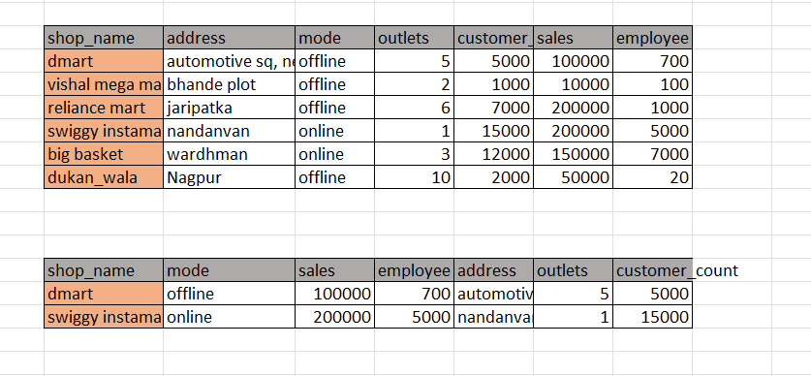

**HLOOKUP, which stands for "Horizontal Lookup," is an Excel function used to search for a value in the top row of a data table and return a corresponding value from a different row in the same column. It's the horizontal counterpart to the more common VLOOKUP function.**

**How it Works ⚙️**

**The basic syntax for HLOOKUP is:**

**=HLOOKUP(lookup_value, table_array, row_index_num, [range_lookup])**

* **lookup_value: The value you want to find. This value must be located in the top row of your data table.**
* **table_array: The range of cells that contains all the data you want to search.**
* **row_index_num: The row number (within your table_array) from which you want to retrieve a value. For example, if the top row is row 1, the row immediately below it is row 2, and so on.**
* **[range_lookup]: This optional argument determines the type of match.**
  + **TRUE (or omitted) finds an approximate match. Use this when your data is sorted in ascending order.**
  + **FALSE finds an exact match. This is the most common and reliable option.**

**Key Differences from VLOOKUP**

**The primary difference between HLOOKUP and VLOOKUP is the orientation of the data they search.**

* **HLOOKUP searches horizontally across a row. It is used when your data headers are in the first column and your data is spread out across rows.**
* **VLOOKUP searches vertically down a column. It's used for the more common table format where headers are in the first row and data is arranged in columns.**

**Because most spreadsheets are set up with data arranged vertically in columns, VLOOKUP is generally used more often than HLOOKUP.**

**How to Use HLOOKUP in Excel**

**This video provides a tutorial on how to use the HLOOKUP function in Excel with examples.**